Vending Machine Project

We've all used vending machines. But have you thought about the logic and programming that is required to make one of these machines work?

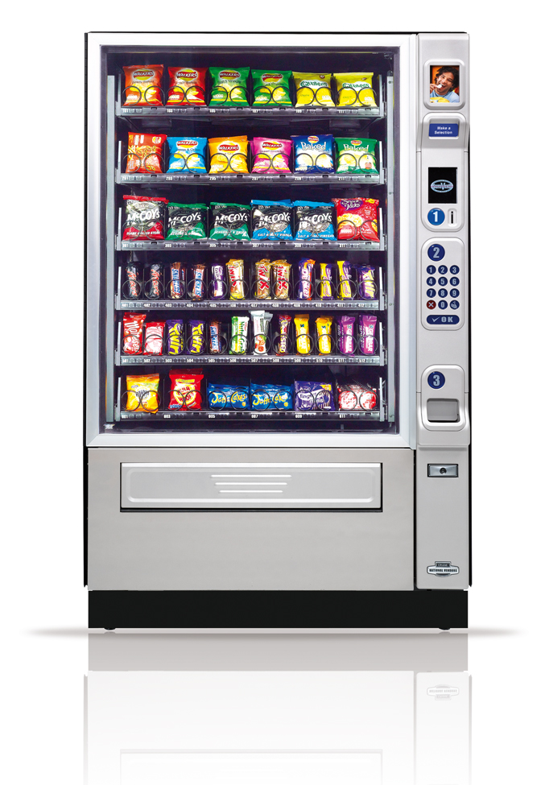

Here is a typical vending machine. We're going to write the software that it uses to run. Before we jump into coding, let's talk about the steps you go through when buying a snack.

1. User inserts money (our vending machine only accepts coins -- no bills and no cards).
2. User enters their selection (a two-digit number in this case)
3. Is the number the user entered valid?
   1. If yes, proceed to next step.
   2. If no, alert the user to try again. Return to step 2.
4. Is the item in stock?
   1. If yes, proceed to next step.
   2. If no, alert the user to choose something else. Return to step 2.
5. Did the user insert enough money to purchase that item?
   1. If yes, proceed to next step.
   2. If no, alert the user of the price for that item. Return to step 2.
6. Machine releases the selected item.
7. Machine returns the most efficient amount of change to the user.

Okay. Hopefully, you are starting to realize that there is a little bit more to the vending machine than what you can see on the outside.

This assignment is going to require you to work in groups. Each student will be working on DIFFERENT code. If everything goes correctly, you'll be able to merge your code at the end and have a working vending machine.

In order to help members of the team reach a successful vending machine, I'll go ahead and give you the layout of the program. Then, all you and your partners need to do is implement the program *exactly* as I describe it. Easy, right?

I’ve posted an API at <http://brandonshows.me/vendingmachine/doc>. This site contains all the classes that need to be implemented, as well as all of the public methods. As it turns out, I didn’t make use of any private methods, so everything I did is listed in the API. You’re free to make more helper functions, but they should be **private**!

Additionally, you can download my version of the program at <http://brandonshows.me/vendingmachine/VendingMachine.jar>. To run this program, open the folder that contains the JAR file. Then, type “cmd” in the navigation bar. Press “Enter.”

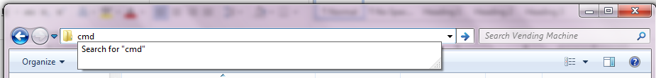

A command prompt will open. Type in the following command:

**java –jar VendingMachine.jar**

This will allow you to play around with my code while you are implementing your own.

The rest of this document contains extra hints not found in the auto-generated API. Good luck!

Here is a list of classes and the instance variables I used:

# Cashier.java

// The amount of change the user has inserted for the current transaction.

private int currentCents;

# InventoryManager.java

// An ArrayList containing all ProductManager objects added to the

// InventoryManager.

private ArrayList<ProductManager> allProducts;

# Product.java

// The name of the snack.

private String snackName;

// The cost of the snack (in cents).

private int costInCents;

# ProductManager.java

// A static string keeping track of the last itemCode used.

private static String nextItemCode = "A1";

// The itemCode managed by each object.

private String itemCode;

// The Product this ProductManager is managing.

private Product product;

// The number of said Products loaded into the Vending Machine.

private int quantity;

# VendingMachine.java

// A Cashier object for the Vending Machine.

private Cashier cashier;

// An InventoryManager object for the Vending Machine.

private InventoryManager im;

// A Scanner object to get keyboard input.

private Scanner keypad;